Name: K Suma Smitha

Roll no: 15IT123

Topic: Design Diagrams for library management system

*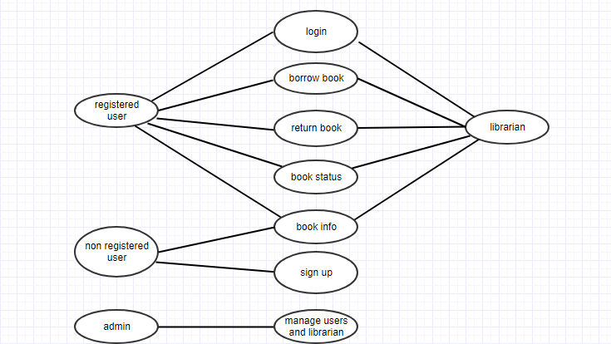*

Figure 1: Use Case Diagram for library management system

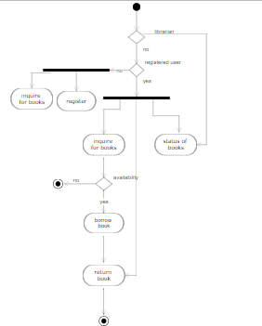

Figure 2: Activity Diagram for library management system

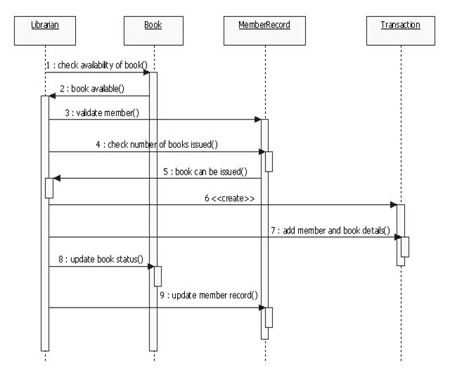 Figure 3: Sequence Diagram for library management system

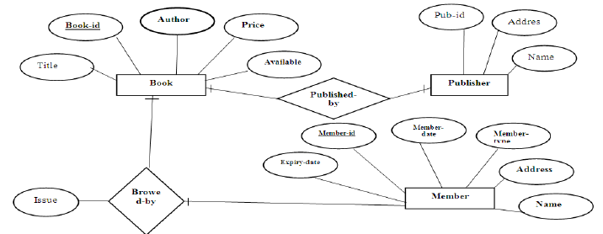

Figure 4: Entity Relationship Diagram for library management system

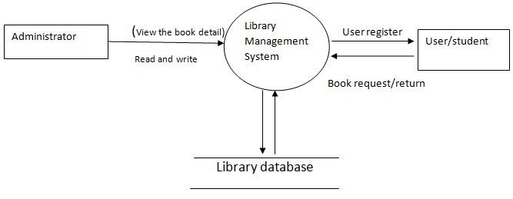

Figure 5: Flow Diagram for library management system